International Scientific Conference
16 – 17 November 2012, GABROVO

OPTIMIZATION OF CLOTHES CONSTRUCTIONAL PREPARATION USING CAD SYSTEM
V. Petrović,
Tecnichal faculty “M.Pupin” University
of Novi Sad, Zrenjanin, Srbija
vlp@EUnet.rs

M. Stanković, I. Skoko,
Tecnichal faculty “M.Pupin” University Tecnichal faculty “M.Pupin” University
of Novi Sad, Zrenjanin, Srbija of Novi Sad, Zrenjanin, Srbija

A.Zdravković, S.Stefanović
Tecnichal faculty “M.Pupin” University Tecnichal faculty “M.Pupin” University
of Novi Sad, Zrenjanin, Srbija of Novi Sad, Zrenjanin, Srbija

ABSTRACT
Modern business conditions impose that development of manufacturing companies going toward the level where they will be able to respond to market demands in a very short period of time. Therefore, in this paper it was observed constructional preparation of clothes before implementation of CAD system for construction, modeling, and grading of clothes in a real conditions of production in selected example of medium enterprise in Serbia. It was determined that less time is required for constructional preparation of various garment by using CAD system compared with traditional way of constructional preparation. The results show that time for constructional preparation was reduced to 33.31% for model M1 - children wrapover vest, for model M2 - skirt, the time was reduced by 61.64% and for model M3 - trousers, time was reduced by 65.35%. Despite the good results obtained using the CAD system, it was concluded that a large number of enterprises in Serbia today is not equipped with CAD systems due to high financial investment for this type equipment for production.

Key words: constructional preparation of clothes, clothes manufacturing, clothes production in time, CAD system for garment construction.

INTRODUCTION

Equipment level of companies for apparel production, which in Serbia has around 950, is different. The environment and conditions under which these firms were established in the last few decades have led that large number of firms was not based on the engineering knowledge, which follows the production of clothing. Clothing industry has big problems especially in countries which are in transition. Nowadays, it is common to hear that the Clothing and Textile industries are in crisis, that production is reduced, sales is reduced, working hours are reduced, and that those industries are operating with losses. Those facts indicate that textile companies have difficulties to adapt to new business conditions, i.e. environment gives them less opportunity to do business successfully. It is evident that certain number of companies can not manage in the new conditions [1,2].
Where we should seek the reasons for poor conditions in Serbian textile industry, once with very successful companies? Newly created economic circumstances and problems, which follow them, have certainly big influence on production process. The most common issues on which encounter manufacturers of apparel are:
- need for a wider collections and frequent changes of samples
- changes in consumer demands,
- changes of dressing tradition,
- emergence of market saturation
- pressure from imported goods,
- changes in rhythm ordering of the traders, etc.

For getting out of this situation it should be used the experience of those who had the same or similar problems and who had successfully solved those problems. All solutions are mainly based on impressive reduction of costs of all participants in the textile chain. To start solving the problems, it is usually taken analysis of current situation of the company. The analysis usually indicates that there is a fatigue in the functioning of the company. For recovery, it is usually offered the following solutions [1,2]:
- implementation of manufacturing strategy Just-in-Time for resolving unnecessary inventories in stock;
- evenly supply of materials in accordance with the needs of the firms;
- introduction of the CIM concept with electronic computers in the management and flexible manufacturing at all stages;
- introduction of Total Quality Management for a comprehensive quality assurance;
- implementation of integrated marketing for completely guidance all operational functions according to market needs, etc.

Modern business conditions impose that development of manufacturing companies going toward the level where they will be able to respond to market demands in a very short period of time. In accordance with that, the companies have the all-new and very strict organizational and production conditions because in a very short time, they must prepare the production process, to adapt production lines, machinery and equipment and workers for the sudden and rapid changes. To satisfied this requirements, it is necessary that company has modern equipment [3]. Survival on market and success in the competition, is forcing companies to always invent new solutions and to take steps for reducing costs impressively, both in the production and with all the participants in textile chain [1,2].

Therefore, today is resorting to new strategies of apparel production. QRS is a strategy for rapid response to market requirements, for identification of needs and desires of clothing consumers, spotting fashion trends, evidence of increasing demand or lack of certain items on the market. This strategy should ensure responsiveness to market demands for a few days, as is schematically presented in Figure 1 [4], where is shown large difference of previous and contemporary aspirations in completion of garment production [1].
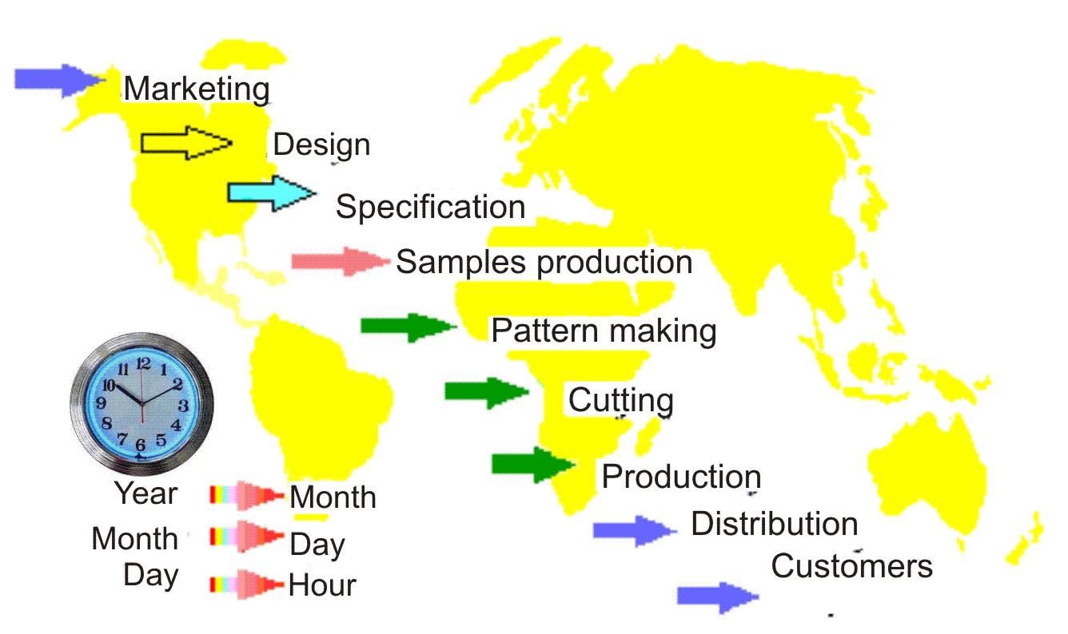
Fig 1: The tendency of reducing the cycle of production of garments

Besides QRS strategies, a special kind of manufacturing strategy - a JIT strategy - just in time or in the given timeframe is imposed on garment manufacturers. This strategy has set completely new and very strict organizational and production conditions for modern garment industry, which are reflected in the preparation of the production process in a very short period of time, and in adapting production lines, machinery, equipment and personnel for the

sudden and rapid changes, which are extra impeded small production series. In this way, activities for production preparation represent a significant factor in these strategies [3].

We have witnessed a numerous of projects in countries in transition which aim at entrepreneurship development. One of these projects in Serbia was the USAID / SEDP project. The goal of SEDP project was to reduce production costs by applying engineering techniques in garment manufacturing with retain quality standards.

Different phases of the project included establishing the order of production operations for all apparel models, definition of appearance of the most efficient work space, establishing the most effective methods of management of making the time study for each operation in order to achieve the correct standard, calculating the number of machines required by the type of machines, setting machines in production lines in the order certain operations, preparing the method for the development of training for each operator and Education checklist for the daily performance of each machine or workstation.

The project included dozens of private apparel companies in Serbia. Project results are reflected in reduction of time required for garments production ranging from 5%, and in some cases up to 40%. Average reduction time for clothes production was ranged around 12%, for all companies in the project. The authors were the participants of USAID / SEDP project. However, it is difficult to present how it was reached to these results , because approach to the problem solving to each company was primarily subjective, and it was based both on the engineering knowledge and personal experience. In addition, each Clothing company was faced with its characteristic problems in their operations and therefore is difficult to make a comprehensive systematization in solving those problems. Therefore, in this paper will be considered a small segment in constructional preparation of clothes on representative example of middle companies.

MATERIALS AND METHODS

By increasing the level of technical equipment of constructional preparation, worker's fatigue is significantly reduced, with a significant increase of productivity. The influence of competition led to a new tendency in making clothes, it is reflected in the reduction in running time of technological operations while maintaining quality, because productivity, production capacity and price garment depend on that. For this reason, during design of clothing products it is necessery to take care about raw material's composition and material properties, as well as the technology of its processing [5-10]. Therefore, in the work it was monitored the differences in constructional prepare for several clothing products before and after introducing CAD systems for design, modeling, and grading into the product line. Analysis was done in into the same company. During analysis it was used French company's software Lectra, more precisely their software package Modaris [4].

Modaris is a program for creating, modeling and grading of cutted parts and assembling the final model. The program offers a fast digitizing of finished cut parts (the process of entering cuts into the existing paper-based
templates in the computer), along with interactive monitoring of input process directly on the screen. Digitizing line is a precise and
simple, with few points and all the details of the templates may be included in the program. Modaris enables the automatic creation of new cutting pieces from existing (eg, a simple and rapid preparation of linings, interlinings, etc.) or the construction of new cutting parts directly on the screen using a special function for the base construction using advanced drawing tools.
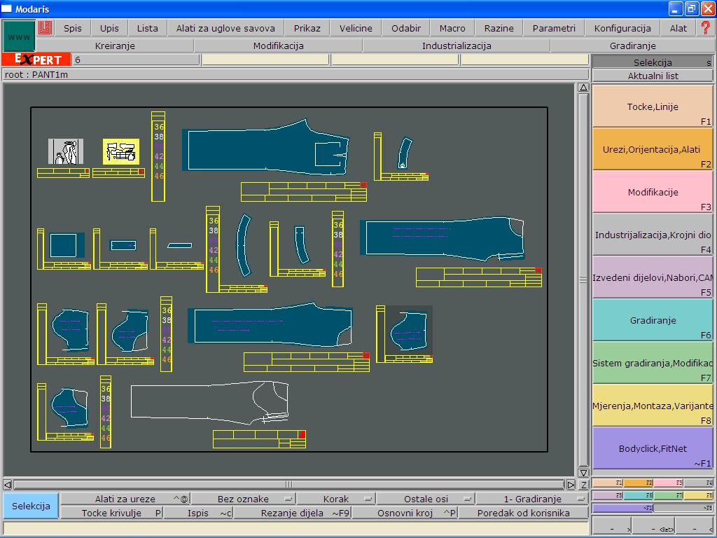
Fig.2.Display of cutting parts on Modaris desktop

Creating different types of internal and external incisions, placement of various internal marks, special text printing within certain parts of the cut parts, advanced techniques of measurement and control, making creases are just a few of the many possibilities offered by this program. With its functions for quick and easy modification of existing cut parts depending on the current needs of the manufacturing process, Modaris contributes to the reduction of time for construction preparation and increases the productivity of associated department. The program allows you to work with the sewing lines or cutting lines, which provides more choices for special seam angles, and their mutual adjustment. Measurements by this program can be perform on the lines of cutting and/or on the sewing lines, and can be measured the volume and surface of the cut parts, and segment's angles. Dynamic table of measurement allows control of cut parts using various measuring formula for addition, subtraction, multiplication, division and graphical representation of each measurement. Using functions to create variants in the model, models are prepared for making cutting patterns. At that point, it is selected type of material and number of peaces that are used in the cutting pattern.
Playing the traditional method of grading, Modaris offers features for fast interactive grading, transfer of grading from already graded to ungraded cutting parts, automatic calculation of proportional grading, and orientation of grading in defined directions. Control of performed grading is simple and precise, and it can be done at each point and each size.
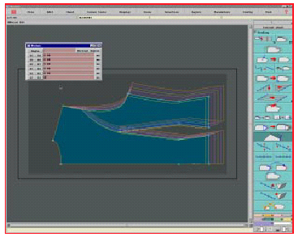
Fig. 3 : Display of grading cutting part on Modaris desktop
In this study, tasks of constructional preparing was observed for three different clothing items in five clothing sizes including: wrapover vest (model M1), skirts (model M2) and pants (model M3). Wrapover vest is made from 100% cotton, trousers and skirt from cloth of mixtures of 97% cotton and 3% elastane. Tables 1 and 2 show the duration of the tasks of the traditional constructional preparation and constructional preparation with the use of CAD systems. The observed workers in constructional preparation were with approximately the same working experience. Workers have had great experience in the traditional way of constructional preparation, and their training to work with the CAD system lasted 4-5 months, which is a short period of time for workers to acquire a maximum of all program options offered by the software package Modaris.

Table 1. Time (in minutes) of duration of the tasks of traditional constructional preparation
The observed activities | Time[min], for models
The observed activities | M1 | M2 | M3
Construction of the basic pattern | 57 | 75 | 92
Modeling | 40 | 111 | 102
Completing | 70 | 122 | 97
Grading | 72 | 362 | 252
Total time in minutes | 239 | 670 | 543

Table 2: Time (in minutes) duration of the constructional preparation with the use of CAD systems
The observed activities | Time[min], for models
The observed activities | M1 | M2 | M3
Construction of the basic pattern | 57 | 75 | 92
Modeling | 25 | 70 | 60
Completing | 45 | 70 | 45
Grading | 15 | 17 | 15
Total time in minutes | 15 | 25 | 25
Construction of the basic pattern | 157 | 257 | 237

Marks in tables 1 and 2 have this meaning
M1 – wrapover vest model,
M2 – skirt model i
M3 – pant model.
Figures 4, 5 and 6 present the advantages of using CAD systems to the traditional way of the structural preparation of models for presented clothes.
Fig. 4: Comparative duration (in minutes) constructional preparation of model M1
Fig. 5: Comparative duration (in minutes) constructional preparation of model M2
Fig. 6: Comparative duration (in minutes) constructional preparation of model M3

Conclusion
Work in the clothing industry is devided on a large number of technological operations of making clothes. Every technological operation is time limited and requires considerable mental and physical involvement of employees. The success of the production of clothing largely depends on the structure and time duration of technological processes. Therefore, in this work the constructional preparation was observed, because it has big influence on the speed of production, ie. on the speed of production response to market demand. The observed workers in constructional preparation were with approximately the same working experience. Workers have had great experience in the traditional way of constructional preparation, and their training to work with the CAD system lasted 4-5 months, which is a short period of time for workers to acquire a maximum of all program options offered by the software package Modaris. Regardless of this fact, the same employees achieve significantly better performance using a CAD system. The results show that for the model M1 - wrapover vest, time for constructional preparation was reduced by 34.31%, for model M2 - skirt, the time was reduced to 61.64% for model M3 - trousers, time was reduced by 65.35%. This time can be significantly reduced by using advanced software functions available in software package Modaris. The results show that using of CAD systems can significantly speed up the production preparation, which is very important in order to satisfy requirements of large consumer markets of clothes that have a constant tendency to reduce the time of making clothes.
Despite the good results obtained using the CAD system, large number of enterprises in Serbia today is not fully equipped with these systems due to the high cost of CAD systems.

Literature

[1] V. M. Petrović: Savremene tehnologije u odevnoj industriji, II Scientific professional meeting of the textile industry in Western Serbia, Regional Chamber of Commerce Užice, 21-23. september 2006., Ivanjica, Serbia
[2] V. M. Petrović: Uključivanje odevne industrije Srbije i Crne Gore na tržište Evropske unije, I Scientific professional meeting of the textile industry in Western Serbia, Regional Chamber of Commerce Užice, 21-23. october 2004., Arilje.
[3]Rogale D.,:“Odjevna tehnologija na svršetku milenijuma – stanje i predvidivi pravci razvitka”, Tekstil 47,1,1998.pp.2-19.
[4] Technical informations from web adress www.lectra.com, accessed 10.05.2012.
[5] D. T. Stojiljković. Ž. Živković, Dinamika sistema projektil - predja pri transportovanju potke kroz zev, M.Sc. Thesis, Faculty of Technology, Leskovac,1998.
[6] D.T. Stojiljkovic, D.M. Pejic, V.M. Petrovic: Rheological models and memory functions of yarn extension, Vlakna a textil, No. 9 (1), str. 17-23, (2002).
[7] J. Stepanovic, B. Antic, M. Stamenkovic, Melliand Textilberichte, No. 9, 2002, pp. 627-630.
[8] V.M.Petrović, J. Đorđević, G.Čolović, D.Paunović: Ispitivanje dimenzione stabilnosti i ocena oštećenja 1x1 rebraste pletenine pri konfekcioniranju, Tekstilna industrija 11 – 12, Belgrade, (2002).

