OPTIMIZATION OF CUTTING PATTERNS USING CAD SYSTEM

ABSTRACT
Modern business conditions impose that development of manufacturing companies going toward the level where they will be able to respond to market demands in a very short period of time. Therefore, in this paper it was observed constructional preparation of clothes before implementation of CAD system for fitting cutting patterns of clothes. It was determined that less time is required for fitting cutting patterns with multiple size of various garment by using CAD system compared with traditional way of constructional preparation. The results show that time for fitting cutting patterns was reduced to 82.76% for model KS1 - children wrapover vest, for model KS2 - skirt, the time was reduced by 80.00% and for model M3 - trousers, time was reduced by 77.50%. Despite the good results obtained using the CAD system, it was concluded that a large number of enterprises in Serbia today is not equipped with CAD systems due to high financial investment for this type equipment for production.

Key words: optimization of production, clothes, production of clothes on time, CAD system, fitting of multiple sized cutting patterns.

INTRODUCTION

Equipment level of companies for apparel production, which in Serbia has around 950, is different. The environment and conditions under which these firms were established in the last few decades have led that large number of firms was not based on the engineering knowledge, which follows the production of clothing. Clothing industry has big problems especially in countries which are in transition. Nowadays, it is common to hear that the Clothing and Textile industries are in crisis, that production is reduced, sales is reduced, working hours are reduced, and that those industries are operating with losses. Those facts indicate that textile companies have difficulties to adapt to new business conditions, i.e. environment gives them less opportunity to do business successfully. It is evident that certain number of companies can not manage in the new conditions [1,2].
Where we should seek the reasons for poor conditions in Serbian textile industry, once with very successful companies? Newly created economic circumstances and problems, which follow them, have certainly big influence on production process. The most common issues on which encounter manufacturers of apparel are:
- need for a wider collections and frequent changes of samples
- changes in consumer demands,
- changes of dressing tradition,
- emergence of market saturation
- pressure from imported goods,
- changes in rhythm ordering of the traders, etc.

For getting out of this situation it should be used the experience of those who had the same or similar problems and who had successfully solved those problems. All solutions are mainly based on impressive reduction of costs of all participants in the textile chain. To start solving the problems, it is usually taken analysis of current situation of the company. The analysis usually indicates that there is a fatigue in the functioning of the company. For recovery, it is usually offered the following solutions [1,2]:
- implementation of manufacturing strategy Just-in-Time for resolving unnecessary inventories in stock;
- evenly supply of materials in accordance with the needs of the firms;
- introduction of the CIM concept with electronic computers in the management and flexible manufacturing at all stages;
- introduction of Total Quality Management for a comprehensive quality assurance;
- implementation of integrated marketing for completely guidance all operational functions according to market needs, etc.

Modern business conditions impose that development of manufacturing companies going toward the level where they will be able to respond to market demands in a very short period of time. In accordance with that, the companies have the all-new and very strict organizational and production conditions because in a very short time, they must prepare the production process, to adapt production lines, machinery and equipment and workers for the sudden and rapid changes. To satisfied this requirements, it is necessary that company has modern equipment [3]. Survival on market and success in the competition, is forcing companies to always invent new solutions and to take steps for reducing costs impressively, both in the production and with all the participants in textile chain [1,2].

Therefore, today is resorting to new strategies of apparel production. QRS is a strategy for rapid response to market requirements, for identification of needs and desires of clothing consumers, spotting fashion trends, evidence of increasing demand or lack of certain items on the market. This strategy should ensure responsiveness to market demands for a few days, as is schematically presented in Figure 1 [4], where is shown large difference of previous and contemporary aspirations in completion of garment production [1].
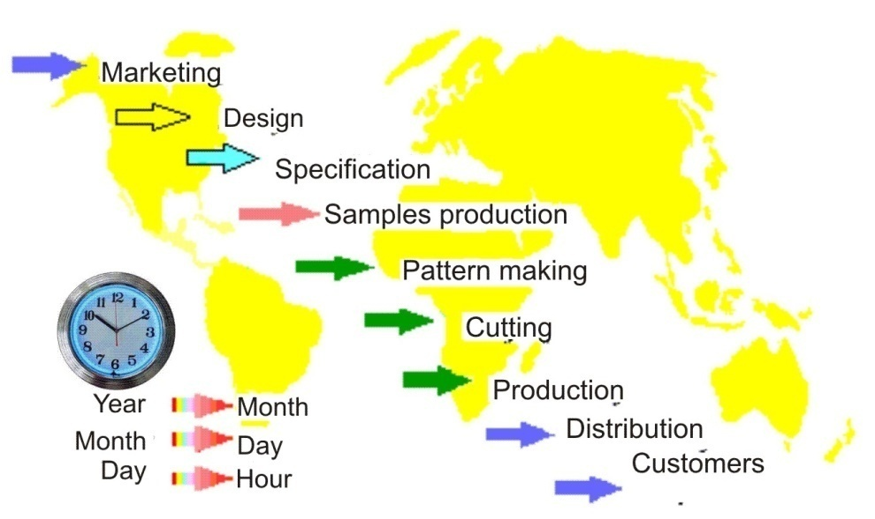
Figure 1: The tendency of reducing the cycle of production of garments

Besides QRS strategies, a special kind of manufacturing strategy - a JIT strategy - just in time or in the given timeframe is imposed on garment manufacturers. This strategy has set completely new and very strict organizational and production conditions for modern garment industry, which are reflected in the preparation of the production process in a very short period of time, and in adapting production lines, machinery, equipment and personnel for the sudden and rapid changes, which are extra impeded small production series. In this way, activities for production preparation represent a significant factor in these strategies [3].

We have witnessed a numerous of projects in countries in transition which aim at entrepreneurship development. One of these projects in Serbia was the USAID / SEDP project. The goal of SEDP project was to reduce production costs by applying engineering techniques in garment manufacturing with retain quality standards.

Different phases of the project included establishing the order of production operations for all apparel models , definition of appearance of the most efficient work space, establishing the most effective methods of management of making the time study for each operation in order to achieve the correct standard, calculating the number of machines required by the type of machines, setting machines in production lines in the order certain operations, preparing the method for the development of training for each operator and Education checklist for the daily performance of each machine or workstation.

The project included dozens of private apparel companies in Serbia. Project results are reflected in reduction of time required for garments production ranging from 5%, and in some cases up to 40%. Average reduction time for clothes production was ranged around 12%, for all companies in the project. The authors were the participants of USAID / SEDP project. However, it is difficult to present how it was reached to these results , because approach to the problem solving to each company was primarily subjective, and it was based both on the engineering knowledge and personal experience. In addition, each Clothing company was faced with its characteristic problems in their operations and therefore is difficult to make a comprehensive systematization in solving those problems. Therefore, in this paper will be considered a small segment in constructional preparation of clothes on representative example of middle companies. Changes in efficacy of constructional preparation when company equips its production with CAD system for fitting cutting patterns of garment will be shown . The same workers who worked on fitting cutting patterns in traditional way were trained for using the CAD system.

MATERIALS AND METHODS

By increasing the level of technical equipment of constructional preparation, worker's fatigue is significantly reduced, with a significant increase of productivity. The influence of competition led to a new tendency in making clothes, it is reflected in the reduction in running time of technological operations while maintaining quality, because productivity, production capacity and price garment depend on that. For this reason, during design of clothing products it is necessery to take care about raw material's composition and material properties, as well as the technology of its processing [5-12]. Therefore, in the work it was monitored fitting of cutting patterns for several clothing products before and after introducing CAD systems for fitting cutting patterns into the product line. During analysis it was used French company's software Lectra, more precisely their software package Diamino [4].

Diamino is a program for making - fitting cutting patterns from models made ​​in Modaris program , and with high-speed performance it provides the reduction of material consumption. It allows fitting of cutting patterns for every type of material and cutting layers. tailoring files for each type of material and debris (open, folded, in the gut, so called open. "face to face"), and operators use it to quickly locate the most effective way of fitting cutting patterns by testing different combinations to find the most usable appearance of cutting patterns and by use of clearly defined rules for the positioning of the cutting parts. All information is printed on cutting parts, fitting process is shown on the screen and it can be continuously monitored. At any moment the cost of material can be seen like and the modifying the quantity, size, and display of all parameters of cutting patterns [4].

The program provides matching cutting patterns on designed (check) materials and accurate positioning of cutting parts according to pre-defined points that are used for matching. In order to achieve fine cutting on each cutting part, it can be added some enlargement (abandon) in centimeters, different spacing from other cutting parts and their grouping for easy fitting.
.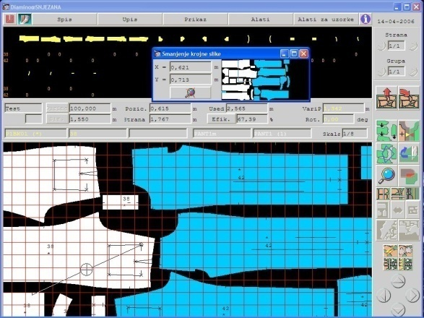 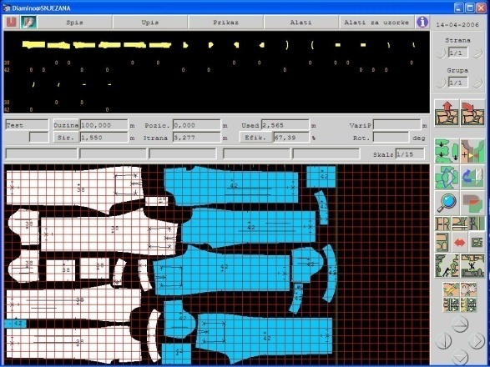
Figure 2: Display of cutting parts on Diamino desktop with turned on option for check materials
During creation of cutting pattern, more patterns could be made at once with different so called restrictions in relation to the material or to the cutting parts (allowed or not turning parts, variants, position of cutting parts for overlap and hose materials) which is used to ensure true parameters in the cutting pattern and to reduce the possibility of error.
Before each memorising of cutting pattern, it is automatic analysed if the cutting parts are mutual overlapped and if there is cutting part which is not incorporated. Special mini keyboard was build for this program, with purpose to speed up the fitting process, which increases speed of execution and increases productivity in the development of cutting patterns.

Diamino is directly linked with other Lectra's applications, primarily Modarisom which is used for modeling. It allows that during modification of the model, all cutting patterns which contain that model automatic include new modification.

Directly from program cutting pattern can be sent to the printing, the automatic spreading or cutting. Program also contains functions for preparation of cutting on the automatic material cutters (cutter), it allows the determination of the starting point, direction of cutting, and optimization of cutting process.

Diamino program includes the following features:
- features and tools that enable creation and easy modification of high-quality embedded cutting patterns from models created in Modaris
- maximum flexibility during fitting of cutting parts, flexibility in changes of quantities, dimensions, displaying and in parameters for each of creating process
- The process of testing a lot of different combinations in order to find the most usable appearance of cutting pattern
- creating of so-called limitations of fitting in order to fit exactly by defined rules
- increasing the parts of the cutting pattern, and fast change of measures for partial or entire displaying of cutting pattern
- automatic recognition of folded parts before saving
- creation of cutting parts on patterned materials, and precise positioning of the cutting parts according to defined matching points
- adding so called leaving on the cutting parts for the sampled materials or for fine cutting
- so called profiles that can store parameters of cutting pattern, and thereby saving time in preparing the following cutting pattern with the same parameters
- special software for fast creating of cutting pattern, which separates processes of creating and fitting
- cutting of cutting pattern at exactly defined position with determined spacing on the cutting spot (it is used for spacing of cutting parts for slitting the so-called. "Progress" tester), as well as cutting the cutting parts in the cutting pattern to get a better utilization
- printing the properties of the cutting pattern for further calculations
- convert of cutting pattern in so-called cutfile for printing and cutting on systems that are not Lectra
- saving several cutting patterns in one file in so called .MKX format for faster sending by e-mail

In this study, tasks of fitting cutting patterns were observed for three different clothing items in multiple sizes cutting patterns including: wrapover vest (model KS1), skirts (model KS2) and pants (model KS3). Wrapover vest is made from 100% cotton, trousers and skirt from cloth of mixtures of 97% cotton and 3% elastane. Tables 1 and 2 show the duration of the tasks of the traditional fitting of cutting patterns, and fitting of cutting patterns with the use of CAD systems. The observed workers on jobs of fitting of cutting patterns were with approximately the same working experience. Workers have had great experience in the traditional way of fitting cutting patterns, and their training to work with the CAD system lasted 4-5 months, which is a short period of time for workers to acquire a maximum of all program options offered by the software package Diamino.

Table 1: Duration time of the tasks of traditional fitting of multiple sized cutting patterns
The observed activities | Time [min]
The observed activities | KS1 | KS2 | KS3
Fitting of cutting patterns | 58 | 110 | 120

Tabela 2: Duration time of fitting multiple sized cutting patterns with the use of CAD systems
The observed activities | Time [min]
The observed activities | KS1 | KS2 | KS3
Fitting of cutting patterns | 10 | 22 | 27
Marks in tables 1 and 2 have this meaning:
KS1 – cutting pattern 1- wrapover vest,
KS2 – cutting pattern 2 - skirt
KS3 – cutting pattern 3 - pant.

Figures 4, 5 and 6 present the advantages of using CAD systems to the traditional way of fitting cutting patterns of models for presented clothes.

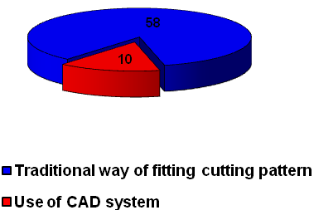Figure 4. Comparative duration (in minutes) of fitting cutting pattern for wrapover vest model
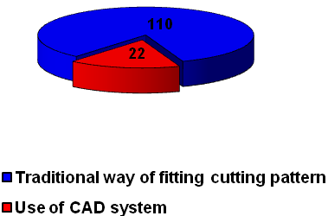Figure 5. Comparative duration (in minutes) of fitting cutting pattern for skirt model

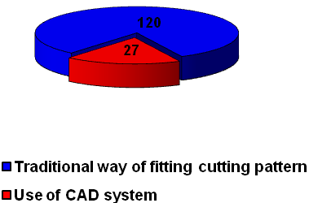
Figure 6. Comparative duration (in minutes) of fitting cutting pattern for pants model

Conclusion

Work in the clothing industry is devided on a large number of technological operations of making clothes. Every technological operation is time limited and requires considerable mental and physical involvement of employees. The success of the production of clothing largely depends on the structure and time duration of technological processes. Therefore, in this work fitting of cutting patterns was observed, because it has big influence on the speed of production, ie. on the speed of production response to market demand. The observed workers, who worked on fitting cutting patterns were with approximately the same working experience. Workers have had great experience in the traditional way of fitting cutting patterns, and their training to work with the CAD system lasted 4-5 months, which is a short period of time for workers to acquire a maximum of all program options offered by the software package Diamino. Regardless of this fact, the same employees achieve significantly better performance using a CAD system. The results show that for KS1 - wrapover vest, time for fitting cutting patterns was reduced by 82.76%, for KS2 - skirt, the time was reduced to 80.00% for KS3 - pants, time was reduced by 77.50%. This time can be significantly reduced by using advanced software functions available in software package Diamino. The results show that using of CAD systems can significantly speed up the production preparation, which is very important in order to satisfy requirements of large consumer markets of clothes that have a constant tendency to reduce the time of making clothes.

5. Literature

[1] V. M. Petrović: Savremene tehnologije u odevnoj industriji, II Naučno- stručni skup Tekstilne industrije Zapadne Srbije, Regionalna privredna komora Užice, 21-23. septembar 2006., Ivanjica.
[2] V. M. Petrović: Uključivanje odevne industrije Srbije i Crne Gore na tržište Evropske unije, I Naučno-stručni skup Tekstilne industrije Zapadne Srbije, Regionalna privredna komora Užice, 21-23. oktobar 2004., Arilje.
[3]Rogale D.,:“Odjevna tehnologija na svršetku milenijuma – stanje i predvidivi pravci razvitka”, Tekstil 47,1,1998.pp.2-19.
[4] Tehničke informacije sa adrese www.lectra.com, pristupljeno 10.04.2012.
[5] D. T. Stojiljković. Ž. Živković, Dinamika sistema projektil - predja pri transportovanju potke kroz zev, magistarski rad, Tehnološki fakultet u Leskovcu,1998.
[6] D.T. Stojiljkovic, D.M. Pejic, V.M. Petrovic: Rheological models and memory functions of yarn extension, Vlakna a textil, No. 9 (1), str. 17-23, (2002).
[7] J. Stepanovic, B. Antic, M. Stamenkovic, Melliand Textilberichte, No. 9, 2002, pp. 627-630.
[8] V.M.Petrović, J. Đorđević, G.Čolović, D.Paunović: Ispitivanje dimenzione stabilnosti i ocena oštećenja 1x1 rebraste pletenine pri konfekcioniranju, Tekstilna industrija 11 – 12, Beograd, (2002).
[9] J.Đorđević, G.Čolović, D.Paunović, V.Petrović: Izbor i ocenjivanje tekstilnih materijala za odevne predmete na bazi potreba potrošača, Zbornik sa V simpozijuma "Savremene tehnologije i privredni razvoj",Tehnološki fakultet, Leskovac, (2003).
[10] G.Čolović, V.Petrović, J.Đorđević, D.Paunović: Analiza metoda za određivanje vremena izrade odevnih predmeta, Zbornik sa V simpozijuma "Savremene tehnologije i privredni razvoj", Tehnološki fakultet, Leskovac, (2003).

Autors:
Vasilije Petrović, Ph.D
Technical Faculty “Mihajlo Pupin”, University of Novi Sad, Zrenjanin, Serbia
vlp@EUnet.rs
Ivana Skoko,
Technical Faculty “Mihajlo Pupin”, University of Novi Sad, Zrenjanin, Serbia
Marija Stanković,
Technical Faculty “Mihajlo Pupin”, University of Novi Sad, Zrenjanin, Serbia
Aleksandra Zdravković,
Technical Faculty “Mihajlo Pupin”, University of Novi Sad, Zrenjanin, Serbia
Sanja Stefanović,
Technical Faculty “Mihajlo Pupin”, University of Novi Sad, Zrenjanin, Serbia

